CUSTOMER EXPERIENCE CONSULTANT WHO TRANSLATES DISNEY’S SERVICE PRINCIPLES TO OTHER INDUSTRIES
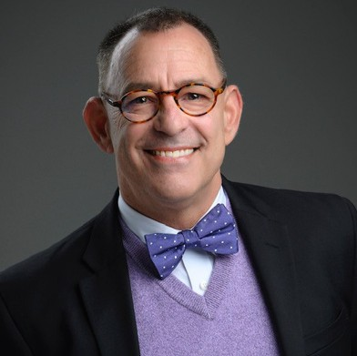
Louie Gravance is often referred to as “the guy that can make the Disney service concepts work outside of Disney.” From 1987 to 2014 Louie enjoyed a distinguished career with Disney theme parks, designing everything from live- entertainment experiences to customer service training programs through the Disney Institute in Orlando Florida.
Following his hugely effective tenure in Orlando, Gravance left Disney to pursue other opportunities and soon amassed even more success working as a consultant, customer service speaker and corporate culture guru.
Louie has designed multi-million-dollar service campaigns
for companies such as ING Financial, Choice Hotels, Microbac Technologies, Nikon and The American Council of Independent Laboratories.
Gravance has been credited with “literally changing the consciousness of business in America” through his service campaigns and initiatives that have included Bank of America’s “The Bank of America Spirit” campaign - deemed the most successful customer service training initiative in the company’s history.
In 2014, his unique entertainment and training experience was called upon to be part of the opening team of Harry Potter’s Diagon Alley expansion at Universal, Orlando.
At only twelve years old, he began working in California as a stage, film and television actor and would go on to appear in over thirty-five national television commercials. In 1987, Gravance was offered a summer job with one of the entertainment industry’s most successful conglomerates, The Walt Disney Company, beginning as a comic at Disneyland in Anaheim, California and soon thereafter embarking on a nearly three-decade adventure at the Walt Disney World Resort in Orlando, Florida.

CUSTOMER EXPERIENCE CONSULTANT WHO TRANSLATES DISNEY’S SERVICE PRINCIPLES TO OTHER INDUSTRIES
Gravance is the recipient of the Disney Partners in Excellence Award and the Spirit of Disney Award and has been recognized internationally as a Disney keynote speaker, having begun his professional speaking engagements on behalf of Disney in 1998.
Through his company Louie Gravance Creative Content, based in Orlando, Florida, Louie continues to offer clients unique training programs with incorporated themes such as “Great Service Serves the Server First!” and powerful initiatives including “Service is a Superpower!”. We’re proud to announce the success of his first book: SERVICE is a SUPERPOWER! (Lessons Learned in a Magic Kingdom) published through Mascot books, and often purchased as a take-away from his live presentations. The book allows clients to take home a guide for developing "The Ten Skills of the Service Superhero".
Louie brings the professional, top tier training he garnered from Disney as a performer to every presentation he hosts. While corporate and employee growth is serious business, humor and heart remain at the center of every Louie Gravance presentation because he also knows, from experience, there’s no business BUT show business.

